PRESS RELEASE
Havenstreet and Ashey Parish Council are preparing to launch a bus survey to gather public opinions on the non existing bus service in Havenstreet. The aim is to identify if there is sufficient public demand to justify the return of a bus service to Havenstreet. They want to hear from as many residents as possible if they would use a regular bus service and non-users to understand how we can attract more people to use bus services in the future.
Chairman Tony Barry said “It’s ten years since Havenstreet lost it’s bus service, Councillors are often urged to get our bus back. This survey is the first step in establishing the demand for a bus or other public transport service, it will give us the evidence we need to lobby the Island Council and Southern Vectis to get the village back on the bus service map”.
The bus survey will be available from 4th August to 15 August 2025. It will be delivered to each household in Havenstreet by Parish Councillor’s and available on the Havenstreet and Ashey Website.
The Parish council hopes to continue to work with the Island’s council and public transport operators to undertake network reviews, with a particular focus on rural bus services to find the most appropriate and financially sustainable opportunities for communities like Havenstreet.

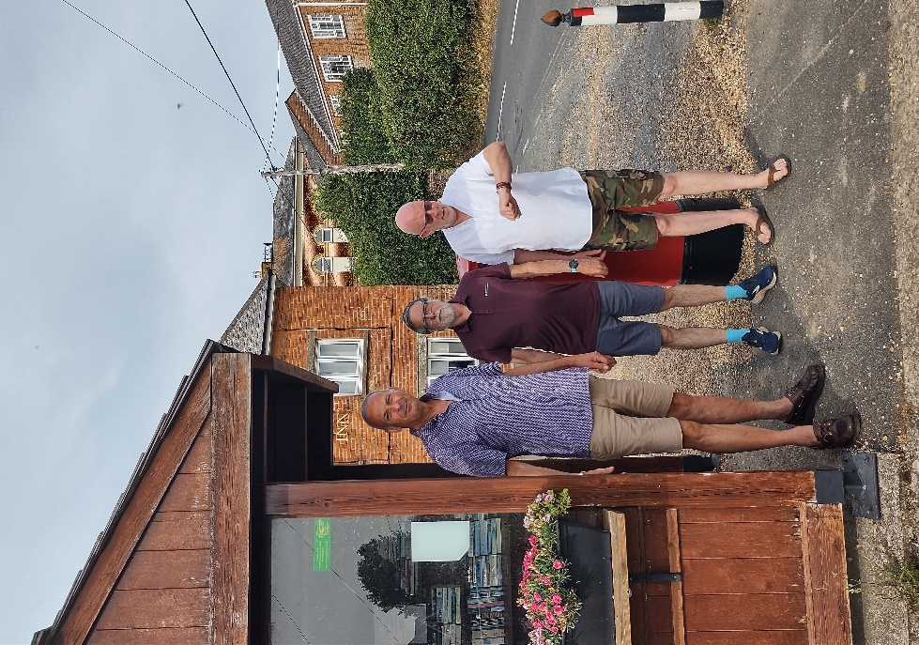
Chairman Tony Barry, Councillor Mick Lyons and Councillor Mark Wilson from Havenstreet and Ashey Parish Council) at the village bus shelter, now a community book stall. The last bus left in 2015.

