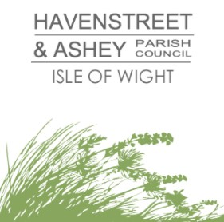
www.havenstreetandasheypc.co.uk
3rd October 2025
PRESS RELEASE – HAVENSTREET VILLAGE BUS SURVEY RESULT PUBLISHED
Havenstreet & Ashey Parish Council have published the result of their 2025 Havenstreet Village Bus Users Survey. The aim of the survey was to collect evidence to determine if, after an absence of ten years, there is the demand for a Havenstreet village bus service and to urge the Isle of Wight Council to take action to deliver on their Bus Service Improvement Plan aspirations.
Following concerns raised over the complete absence of public transport to Havenstreet, the survey was carried out in August, with over 200 survey forms distributed around the village. The survey generated an excellent level of engagement, with 58% of survey forms returned. Analysis of the results show very strong support for the return of a village bus service after an absence of ten years.
Survey respondents highlighted the benefits a bus service will deliver for residents by reducing social isolation and enabling travel to work, school, and social facilities. In addition it was highlighted that access to a public transport service would have a positive impact on road safety in the area.
Council Chair Tony Barry commented “We’ve had a fantastic response to the survey and would like thank everyone that took the time out to reply. There’s now strong evidence of demand for the return of a bus service to Havenstreet, we are hopeful of a positive response from the Isle of Wight Council”

ADDITIONAL INFORMATION:
In September 2015 Southern Vectis Route 33 and Community Bus Route 34/34a ceased operating The village of Havenstreet has been without a bus service for ten years.
Havenstreet’s closest accessible bus service is the Route 37 (Ryde Town Service) which passes approximately 500 metres from the edge of the village. Access to this service involves walking along an unlit country road without a pedestrian footpath. This is not a safe option for many residents.
Section 5 of the Isle of Wight Council’s Bus Service Improvement Plan states ‘It is the Council’s aspiration to establish or re-establish supported services, either by traditional contracted services fully supported using available budgets or through Demand Responsive Transit (DRT). The primary focus will be for isolated rural communities who have not had a regular bus service since at least 2015’. The village of Havenstreet fits this criteria.
POINT OF CONTACT:
Raine Ellis, Parish Clerk - clerk@havenstreetandasheypc.co.uk
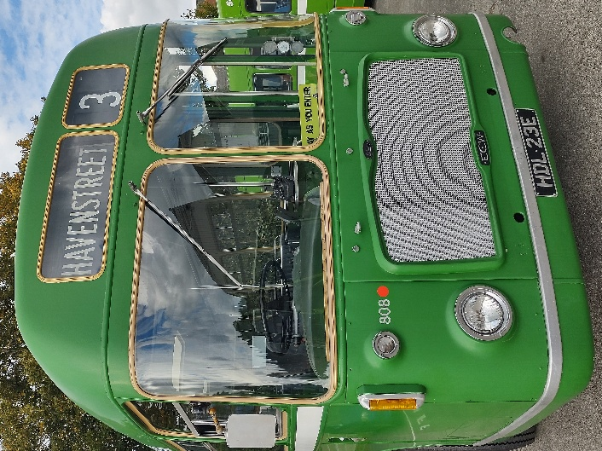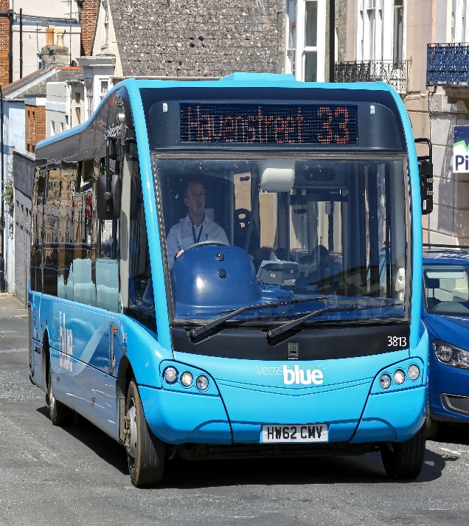

Route 3 Vintage Bus – It’s many years since Route 3 linked Havenstreet with Ryde and Newport, is a return on the cards?
Havenstreet Route 33 Bus – Route 33 on the way to Havenstreet, a service withdrawn in 2015. Credit – Trevor Whelan.

